**Project 1-Data Visualization project (Tool-R)**

**Source of Data:** [The Economist](http://www.economist.com/node/21541178) or <https://www.economist.com/graphic-detail/2011/12/02/corrosive-corruption>

Tools: R/Mentor: Udemy/plot library: GGplot2

Assignment: recreating plot by showing a correlation between **corruption and development**

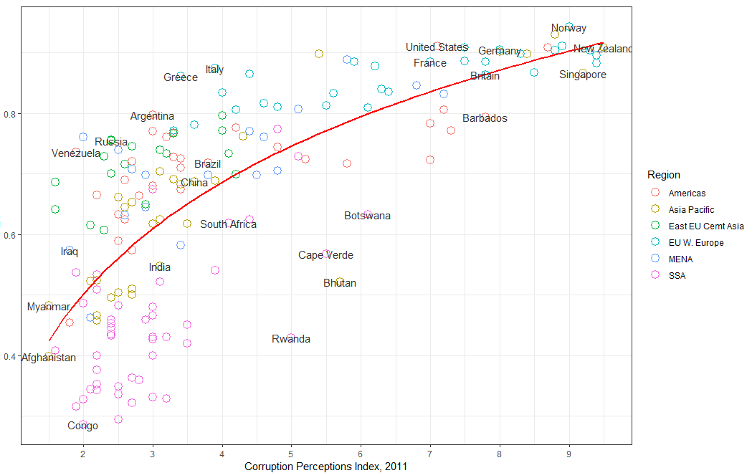

**Project-2 Find out Sales trend of bike Rental (Tools-R)**

**Source:** [Bike Sharing Demand Kaggle challenge](https://www.kaggle.com/c/bike-sharing-demand/data)! Or <https://www.kaggle.com/c/bike-sharing-demand/data>

**Assignment: - how many bike rentals would we predict if the temperature was 25 degrees Celsius?**

Exploration of Temperature datawise count

Explaination: **we can see most of sales happen in the mid or summer and fall**

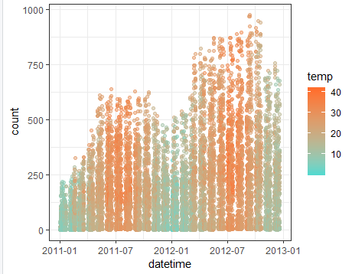 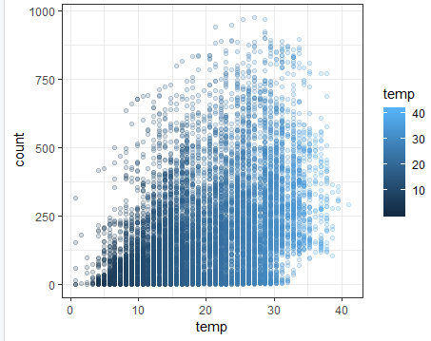

Exploration of sassional datawise count

Explaination: **data doesn’t looklike good for Linier side(cant draw Linier curve)**

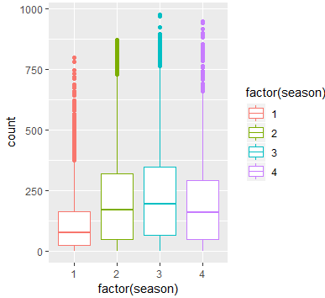

Exploration of hours and temperature wise count

**Data shows from working days in week Data shows from Non-Working day in week**

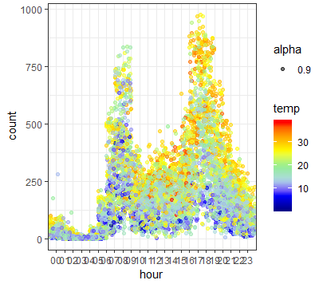 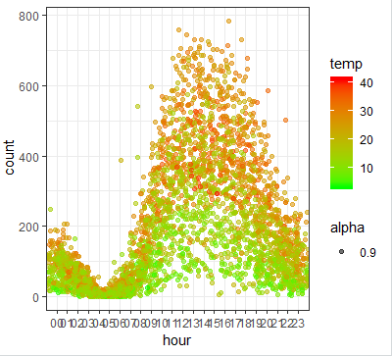

Explaination: noticed that working days have peak activity during the morning (~8am) and right after work gets out (~5pm), with some lunchtime activity. While the non-work days have a steady rise and fall for the afternoon.

**Building Model and Observation**

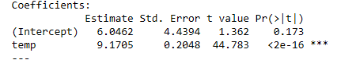

Interpreting the intercept (β0):

* It is the value of y when x=0.
* Thus, it is the **estimated** number of rentals when the temperature is 0 degrees Celsius.
* Note: It does not always make sense to interpret the intercept.
* It is the change in y divided by change in x, or the "slope".
* Thus, a temperature increase of 1 degree Celsius is associated with a rental increase of 9.17 bikes.
* This is not a statement of causation.
* β1 would be negative if an increase in temperature was associated with a decrease in rentals.

**Question: how many bike rentals would we predict if the temperature was 25 degrees Celsius?**

**Answer: 6.0462 + 9.17*25=235.2962**